  Badr University in Assiut |  | 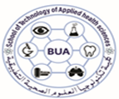  Faculty of Technology of Applied Health Science
Level: | Final Exam |  | Semester:
Program: |  |  | Date:
Course: | Code: |  | Date:
Student name: ……………………………. Student ID: ……………………………………
___________________________________________________________________________________________

With all best wishes,

